Aim  
To change the hardware compatibility of an already created and configured Virtual Machine (VM) in Oracle VM VirtualBox by cloning it or creating a new VM.

**Procedure**

1. Open Oracle VM VirtualBox
   * Launch the VirtualBox application on the host system.
2. Select the VM to Modify
   * Choose the VM whose hardware compatibility needs to be changed.
3. Clone the VM (If Using Clone Method)
   * Right-click the VM and select Clone.
   * Name the clone and choose Full Clone for independent hardware changes.
   * Complete the cloning process.
4. Change Hardware Compatibility by Creating New VM (Alternative)
   * Create a new VM in VirtualBox with the desired hardware settings.
   * When asked to create a hard disk, select Use an existing virtual hard disk file and browse to link the original VM’s virtual disk.
5. Adjust Hardware Settings in VM
   * Select the cloned or new VM and click Settings.
   * Under System, adjust:
     + Base Memory (RAM)
     + Processor count
     + Enable/disable EFI (Extensible Firmware Interface)
   * Under Display, adjust video memory and other display options.
   * Under Storage, verify or change virtual disk attachment if needed.
   * Change other hardware settings such as network adapters or USB controllers as required.
6. Save Settings and Start VM
   * Click OK to save hardware configuration changes.
   * Start the VM to verify it boots correctly with the new hardware compatibility settings.

**Output:**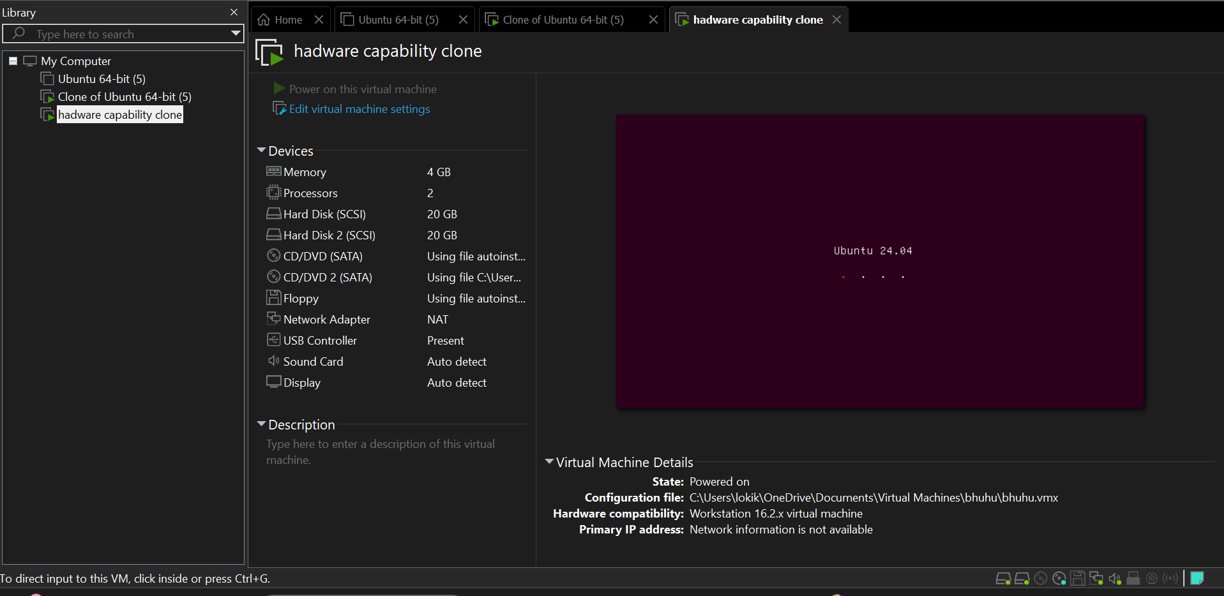

**Result**

The hardware compatibility of the Virtual Machine was successfully changed in Oracle VM VirtualBox by cloning the VM and modifying its settings or by creating a new VM and attaching the existing virtual hard disk. The modified VM started and operated correctly with the updated hardware configuration.